PROTECT
Care -
Not Killing

To help you make a Submission to the investigation into ending one’s life in New Zealand (suicide, assisted suicide, euthanasia), we have prepared the following:

- Briefing Paper: “A Call for Care, Not Killing” – This document contains the key reasons why the current laws opposing suicide / assisted suicide / euthanasia should be maintained. The information in this document can help form the basis of your own Submission. It will give you a head start, and perhaps clarify any questions that you personally have.
- How to make a Submission – Don’t know where to start? We’ve listed the key information you need to include, the ways you can send your submission in, and other relevant information. All you need to do is then tell the Select Committee your view. Simple!
- The final date for Submissions is February 1 2016, but the Select Committee is already receiving submissions. Why not do yours this week?!

For further information, go to
PROTECT.ORG.NZ

A Call For Care, Not Killing

EUTHANASIA DEFINED
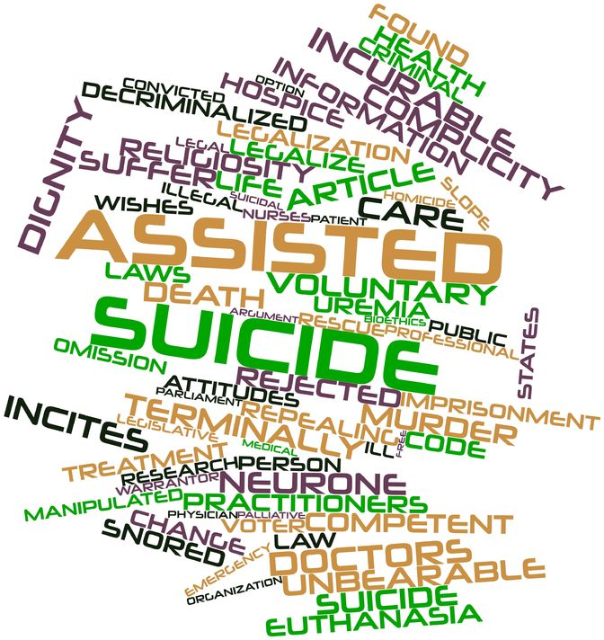
In the euthanasia debate there are a number of terms used more or less interchangeably - euthanasia, mercy killing, physician-assisted suicide, assisted dying, withdrawal of life-prolonging treatment - but the concepts are not identical and are often not well-understood.
Voluntary Euthanasia is the act of intentionally, knowingly and directly causing the death of a patient, at the request of the patient, with the intention of relieving intractable suffering. If someone other than the person who dies performs the last act, euthanasia has occurred. Euthanasia is involuntary where the person is able to give consent but has not done so or where a person was euthanised against their will, and non-voluntary where the person lacks capacity to give consent or request to end his or her life.

Assisted Suicide is the act of intentionally and knowingly providing the means of death to another person at that person’s request in order to facilitate their suicide. Assisted suicide occurs where a person self-administers the lethal substance that has been obtained with the assistance of a third party. Physician–assisted suicide is where the person providing the means (e.g. lethal drugs) is a medical practitioner.doctor.

WHAT IS NOT EUTHANASIA
The administration of pain relief
Everyone has a right to effective pain relief. The administration of drugs in doses sufficient to alleviate pain and suffering rarely causes death and it is permitted and it is ethical. From time to time, a patient may die whilst receiving such drugs. That is not euthanasia, since the death of the patient was not the intended outcome of the medication. The Australian and New Zealand Society of Palliative Medicine (ANZSPM 2013) states: “Treatment that is appropriately titrated to relieve symptoms and has a secondary and unintended consequence of hastening death, is not euthanasia.”

The withdrawal of burdensome and futile life-prolonging treatment
The common practice of withdrawing futile medical assistance from a patient for whom it is not accomplishing anything useful, despite this action potentially being associated potentially with the person’s death, is lawful. legally permitted. There is no legal or ethical requirement that a diseased or injured person must be kept alive at all costs. The law has drawn a clear and consistent line between withdrawing medical support and thereby allowing the patient to die of his or her their own medical condition, and intentionally bringing about the patient's death by a positive act.

WHAT DOES THE LAW CURRENTLY SAY ABOUT SUICIDE?
s 179 of the Crimes Act 1961 (NZ) states that “Everyone is liable to imprisonment for a term not exceeding 14 years who—(a) incites, counsels, or procures any person to commit suicide, if that person commits or attempts to commit suicide in consequence thereof; or (b) aids or abets any person in the commission of suicide.” Furthermore, under s 151 there is a duty to provide “necessaries” of life to those who have the care or charge of a “vulnerable adult” who is unable to provide himself or herself with these essentials.

Move the heading “What about my Choice?” down onto this page ie
WHAT ABOUT MY ‘CHOICE’?
It is important to note that a person may refuse medical treatment and may do so even if it results in his or her death. Section 11 of the New Zealand Bill of Rights Act 1990 reinforces this common law right by providing that “everyone has the right to refuse to undergo any medical treatment.” The Australian and New Zealand Society of Palliative Medicine (ANZSPM 2013) states: “Patients have the right to refuse life sustaining treatments including the provision of medically assisted nutrition and/or hydration. Refusing such treatment does not constitute euthanasia.” Complying with such a refusal does not constitute euthanasia.

ABUSE – EVEN WITH ‘SAFEGUARDS’
As a NZ Herald editorial put it - “devising a robust euthanasia regime, complete with adequate safeguards, seems hardly feasible.” The potential for abuse and flouting of procedural safeguards is a strong argument against legalisation. A recent An overseas study found that 32 percent of all assisted deaths in the Flemish region of Belgium are done without explicit request. The legal requirement to report euthanasia has not been fully complied with in those nations either. The terminally ill and those suffering great pain from incurable illnesses are often vulnerable. And not all families, whose interests are at stake, are wholly unselfish and loving. There is a risk that assisted suicide may be abused in the sense that vulnerable people may be persuaded that they want to die or that they ought to want to die.

SLIPPERY SLOPE Mission Creep
Many critics emphasise the inevitable extension of euthanasia over time - the so-called “mission creep” or “slippery slope” phenomenon. There is unarguable empirical evidence from those nations countries that have authorised euthanasia, that the availability and application of euthanasia expands to situations never initially envisaged as indications for it. So, for example, euthanasia has been extended to enable minors to avail themselves of it (albeit with parental consent) in the Netherlands and Belgium.


Based on From overseas experience, it is extremely likely that if legalised in New Zealand, euthanasia will become a mechanism in N.Z. to terminate the lives of those who do not consent to it as well those who do consent., That is, it will it degenerate into involuntary euthanasia. It will be available to, and thus come to be utilised by, minors. It will be applied to new-born infants with disabilities. Once society accepts one form of euthanasia active termination of human life restricted to a precise set of conditions, it will be difficult or impossible to confine euthanasia to those conditions. For instance, if one allows euthanasia for adults suffering from incurable terminal diseases, then what prevents those with curable diseases from demanding this “treatment”? (Maryan Street’s proposed Bill already had this extended availability).

When a newly-permitted activity is characterised as a “human right” there is often a constituency who will lobby to extend such a right to a greater number of persons. If some citizens are currently deprived of enjoying this newly-minted right, then “equality” and non-discrimination demands that they be granted it too.

Professor Theo Boer was a member of the Dutch Regional Euthanasia Commission for nine years, during which he was involved in reviewing 4,000 cases. He admitted to being a strong supporter of euthanasia and argued originally that there was no ‘slippery slope’. However, by 2014 he had had a complete change of mind. He testified to UK politicians considering the issue:
“Whereas in the first years after 2002 hardly any patients with psychiatric illnesses or dementia appear in reports, these numbers are now sharply on the rise. Cases have been reported in which a large part of the suffering of those given euthanasia or assisted suicide consisted in being aged, lonely or bereaved. Some of these patients could have lived for years or decades.”

‘RIGHT TO DIE’ OR ‘DUTY TO DIE’

Procedural safeguards that require the patient’s consent look convincing in theory. In practice, such safeguards can only go so far. Coercion is subtle. The everyday reality is that terminally ill persons and those afflicted with non-terminal, but irreversible and unbearable physical or mental conditions, are vulnerable to self-imposed pressure. They will come to feel euthanasia would be “the right thing to do”, they have “had a good innings”, they do not want to be “burden” to their nearest and dearest.

The feeling by the terminally ill that one does not want to be a burden to others and that euthanasia or assisted suicide would be ‘the decent thing to do’ is to end one’s life, cannot be underestimated. Annual reports by Oregon Public Health contain data on the numbers of patients who reported that part of their motivation to request euthanasia was because they felt a “burden on family and friends”. In most of the years between 1998 to 2012 (10 years out of 15) more than one in three patients perceived themselves as being a burden to their nearest and dearest.

Elderly and ailing patients are all too aware that their increasingly expensive rest home and geriatric care is steadily dissipating the inheritance that awaits their children. Sadly, the more unscrupulous and callous offspring would not be slow in pointing this out either.
BURDEN PLACED ON PATIENTS
Simply offering the possibility of euthanasia or assisted suicide shifts the burden of proof, so that patients must ask themselves why they are not availing themselves of it. Society’s offer of an easy death communicates the message to certain embattled and hurting patients who are struggling, that they may continue to live if they wish, but the rest of us have no strong interest in their survival. Indeed, once the choice of a quick and painless death is officially accepted, resistance to this choice may be seen as being stubborn, eccentric or even selfish.

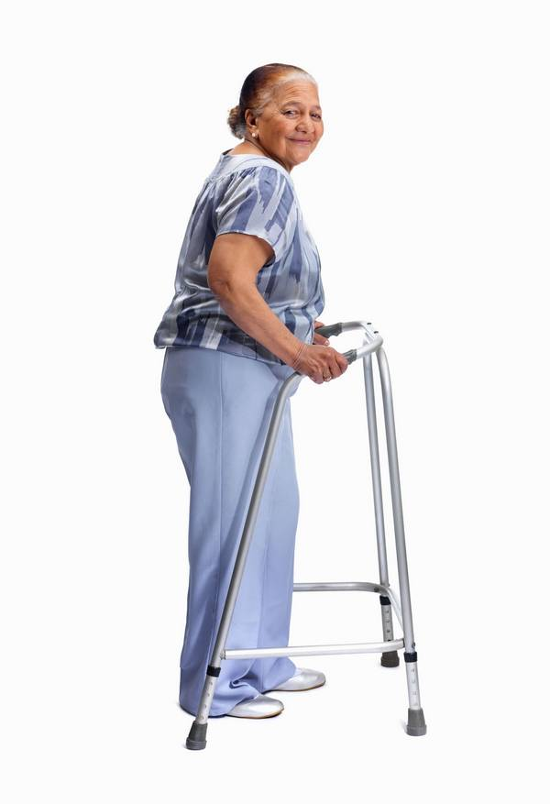
ELDER ABUSE
Emeritus Professor David Richmond contends: “It is older people (and those with disabilities, of whom older people form a large percentage) who actually have the most to fear from legalising these practices…. Older people are, by and large, very sensitive to being thought to be a burden, and more likely than a young person to accede to more or less subtle suggestions that they have “had a good innings.”… (T)hat That is why most District Health Board Boards in the country has have an Elder Abuse team. Hence subtle and not so subtle pressure on older people to request euthanasia where it is available as an option for medical “care” is not always because the family has the best interests of their ageing relative at heart.”

RATIONAL SUICIDE?
The design of a euthanasia or assisted suicide regime is heavily premised on the assumption that persons are clear-minded, rational and free of coercion. But how ‘rational’ a decision can one make when one is suffering from a devastating life event? Research on human decision-making suggests that when a person is suffering, decision-making becomes less rational. Most of the demands for legalising euthanasia and assisted suicide come from exceptional individuals who are intelligent, articulate and who can clearly comprehend their predicament. Yet a euthanasia law the law will have to protect everyone—the inarticulate as well as the articulate, the impaired, gullible or naïve, as well as the intelligent and alert.

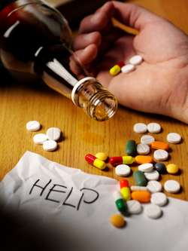
CONFLICTING MESSAGES ABOUT SUICIDE PREVENTION
There will always be concerns about conflicting messages being sent regarding about suicide if when assisted suicide becomes lawful. is available. On the one hand, society will offer offers some suffering individuals assistance to commit suicide, with terminating their lives yet on the other hand, it seeks to take a zero-tolerance approach to individual suicides. The arguments put forward for allowing assisted death can also be reasons given for any suicide. Allowing Legalising euthanasia could potentially institutionalise suicide as a method of coping with personal problems. The risk of ‘suicide contagion’ associated with a media campaign around promoting euthanasia is also a real concern.

DEPRESSION

Many people with depression who request euthanasia revoke that request if their depression and pain are satisfactorily treated. Even very mild depression—of the kind that would not render a person legally incompetent—can have a marked effect on one’s predisposition to live or die. Virtually all patients who are facing death or battling an irreversible debilitating disease are depressed at some point. If euthanasia or assisted suicide is allowed, many patients who would have otherwise traversed this difficult dark phase (and found meaning in continued living) may not get that chance and will die prematurely.

WHAT DO THE MEDICAL PROFESSIONALS THINK?
The majority of the medical profession and national medical associations around the world remain resolutely opposed to the introduction of euthanasia or assisted suicide. The role of the doctor would be irrevocably changed from healer to (at times) sometime killer, from caring professional who saves lives to one who takes them. “Therapeutic killing” would have arrived. Inevitably, patient trust would be eroded.

“The NZMA however encourages the concept of death with dignity and comfort, and strongly supports the right of patients to decline treatment, or to request pain relief, and supports the right of access to appropriate palliative care. In supporting patients’ right to request pain relief, the NZMA accepts that the proper provision of such relief, even when it may hasten the death of the patient, is not unethical.”

THE ‘ELEPHANT IN THE ROOM’

A large amount of the public purse is spent on healthcare for the dying, those with dementia and the elderly. Euthanasia is cheap, good palliative care and hospice services expensive. Bureaucrats are always looking for the cheapest ways to spend health care budgets. This harsh argument from economics is seldom if ever heard issuing from the lips of advocates for euthanasia, but it is arguably ‘the elephant in the room’ in the debate. The cold, fiscal reality is that end of life care is expensive and having citizens opt for an earlier death is associated with substantial government savings. Another smaller-sized ‘elephant’ is the increasing demand for human organs suitable for transplants.

POLLS HAVE CONFUSED THE ISSUE
Opinion polls in New Zealand suggest the majority supports the legalisation of euthanasia and/or assisted suicide. But as we showed earlier, many people simply want to ensure that the administration of pain relief and the withdrawal of burdensome treatment are not treated as illegal. The questions have sometimes been misleading in that they conflate actions that are perfectly legal and moral with those that are unlawful. They consistently ask about a patient in insufferable pain, thus playing on peoples’ fears whilst failing to acknowledge that pain is no longer a good reason for requesting euthanasia. In the 10 years that assisted suicide has been legal in Oregon State, it is doubtful if there has been a single request for it from a person suffering from uncontrolled pain. The continued emphasis on pain suggests a degree of cynicism on the part of those who compile such questions. Support typically drops for euthanasia or assisted suicide when state-funded palliative care is on the table.

WHAT HAS THE OVERSEAS EXPERIENCE SHOWN US?
Facts from Belgium
- Roughly 30% of euthanasia deaths in the Flanders region are performed without patient request or consent (1.8% of all deaths in the region) – those most often euthanised without their request or consent are the elderly, the incompetent, and those dying in hospitals
- Almost 1 in 5 deaths in the Flanders region come at the hands of doctors
- Only about 50% of euthanasia deaths in the Flanders region are reported to the Federal Control and Evaluation Committee as is required by law
- As of 2014, there is no age limit on who may access euthanasia and assisted suicide
- Among those euthanised in the past few years: deaf 45-year-old twins who were going blind; a 44-year-old woman with chronic anorexia nervosa; a 64-year-old woman with chronic depression without informing her family
Facts from Oregon
- From 1998 to 2014, the number of deaths from assisted suicide has increased from 16 to 105 per year – a 556% rise over 16 years
- No healthcare provider was present in over 80% of assisted suicide deaths in 2014—officials do not know under what conditions these people died
- As at 2011, complications had been recorded in 3.7% of all assisted suicide deaths
- Only 2.9% of patients requesting assisted suicide were referred for psychiatric or psychological evaluation in 2014; this is compared to 43.5% in 1999
- At least one study has found that 1 in 6 patients who receive a prescription for lethal drugs have clinical depression
- 40% of patients who requested assisted suicide in 2014 did so out of concern for being a burden on their family; only 12% did so in 1998
Facts from the Netherlands
- Deaths from euthanasia have increased 15% year to year since 2008
- Today, 1 in 7 people die at the hands of their doctors
- Over 40 mobile euthanasia squads operate in the country, with some doctors in each squad euthanising over a dozen patients a year
- Anywhere from 23% to 50% of euthanasia deaths are not reported each year as is required by law
- The Dutch have practiced euthanasia on infants since 2005. It is estimated that about 650 babies a year are killed or allowed to die after birth under the Groningen Protocol. One of the authors of the Groningen Protocol, Professor John Griffiths, believes that the legalisation of euthanasia “assuredly changed” the cultural norms in the Netherlands “in the direction of open acceptance of the legitimacy of termination of life of severely defective newborn babies”
Source: Maxim Institute

Some disturbing cases in the media recently:
Growing number of mentally ill Dutch choosing to be killed at euthanasia clinic Aug 2015
Belgium study Finds Euthanasia Targets Women and People With Depression or Autism July 2015
Deaths among young an unintended consequence of euthanasia movement: Australian mother July 2015
A healthy, 24-year-old woman to be euthanised in Belgium for psychological reasons June 2015
Euthanasia wanted for man in constant pain after having a tumour despite not being terminally ill May 2015
Doctors Killed His Belgian Mom Because She Was Depressed. Now He Speaks Out Against Euthanasia Jan 2015
Elderly Scottish cousins undergo joint euthanasia for fear of being put in separate care homes Feb 2015
Documentary shows Belgian doctor euthanizing a depressed, suicidal woman Jan 2015
Mentally ill patients killed by euthanasia in Holland trebles in a year Oct 2014
Man with same brain cancer as Brittany Maynard (US) has lived 13 years after being given just 6 months Nov 2014
Euthanasia for ‘depressed’ alleged murderer by campaigner Philip Nitschke (Aust) July 2014
Swiss – assisted dying for elderly who are not terminally ill May 2014

THE WAY FORWARD FROM HERE

New Zealand has a well-developed network of hospices and palliative medicine is widely practiced. There is research on the actual experience of those nearing the end of life, indicating that fears of dying tend to dissipate when terminally-ill patients receive good hospice or palliative care. The key priority must be to improve the provision of high quality palliative care and practical support. This should be available in all areas of New Zealand. The highest quality of pain control and palliative medicine should be given priority in medical training so that every New Zealander can benefit. Patients facing death have a fundamental human right – a right to receive the very best palliative care, love and support that we can give to alleviate the ‘intolerable suffering’ that they fear. This is real death with dignity – surrounded and supported by loved ones, rather than a right to try and preempt the ‘uncertainty’ and timing of the end. Assisting suicide is not the answer.

SUMMARY
Voluntary euthanasia and physician-assisted suicide is a complex and challenging subject. Both the advocates and opponents of euthanasia are sincere and committed to what they see as the most humane and prudent policy for society.

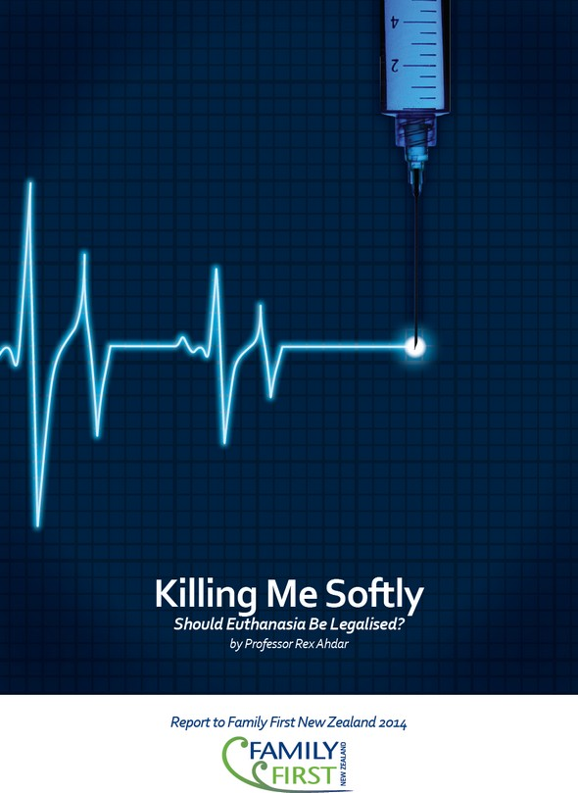
Voluntary euthanasia has the allure of being an enlightened and compassionate response to the plight of the suffering. But its practical operation is fraught with risks and there are slippery slopes that are indeed slippery. Perhaps the most ominous change is one that cannot be proved. There will be an irreversible alteration to the way society and the medical professional view the demise of the elderly, the disabled, the incurably afflicted and the terminally ill. Death will be planned, coordinated and state-sanctioned in a manner hitherto unknown.

We should increase care, support, and funding for the best palliative care regime in the world. But we should not allow euthanasia and assisted suicide.

Source: This information was primarily sourced from the research paper “Killing Me Softly: Should Euthanasia Be Legalised?” by Professor Rex Ahdar (2014). The full paper (including the Executive Summary) can be downloaded for free from our website www.familyfirst.nz

MAKE A SUBMISSION

Details of the Inquiry
http://www.parliament.nz/en-nz/pb/sc/make-submission/0SCHE_SCF_51DBHOH_PET63268_1/petition-of-hon-maryan-street-and-8974-others
The committee will undertake an investigation into ending one’s life in New Zealand. In order to fully understand public attitudes the committee will consider all the various aspects of the issue, including the social, legal, medical, cultural, financial, ethical, and philosophical implications.
The Committee will investigate:
1. The factors that contribute to the desire to end one’s life.
2. The effectiveness of services and support available to those who desire to end their own lives.
3. The attitudes of New Zealanders towards the ending of one's life and the current legal situation.
4. International experiences.

When preparing your Submission, there are a number of things to remember:
- At all times, be positive, respectful and constructive. Highlight what you are FOR - maintaining the current law opposing assisted suicide / euthanasia. Avoid personal attacks, negative labels or angry words.
- If appropriate, include a personal story of how suicide or a terminal illness has affected your family, and how assisted suicide laws would affect vulnerable people. Highlight any examples of palliative care that have made the difference and helped families cope.
- We would strongly encourage you to say YES to appearing before the Select Committee. Making an oral submission provides you with the opportunity to reinforce what you have said in your written submission. We can send helpful guidelines to help you prepare for this.
- When you send your Submission in, please consider also emailing or posting a copy to your local MP. You can find out who your local MP is (and their email address) at our website www.haveyoursay.org.nz (also available as a smartphone app).
- Share your submission with friends and family. It may inspire them to make a submission also.

Please note: SUBMISSIONS ARE DUE BY 1 February 2016. (The Committee will not accept late submissions.) However, we would encourage you to make your submission as soon as possible as the Committee has already started to hear submissions. Please note that submissions are made public unless you specifically request anonymity.

POST
Post 2 copies to:
Committee Secretariat
Health Committee
Parliament Buildings
Wellington 6160

ONLINE
Online submission form is at the bottom of this page:
http://www.parliament.nz/en-nz/pb/sc/make-submission/0SCHE_SCF_51DBHOH_PET63268_1/petition-of-hon-maryan-street-and-8974-others

EMAIL
select.committees@parliament.govt.nz

For further info
Phone: 04 817 9541
Fax: 04 499 0486
Email: select.committees@parliament.govt.nz

Health Select Committee Members
http://www.parliament.nz/en-nz/mpp/mps/current?pf=committeeshortname&sf=health&lgc=0

Suggested layout for Submission via email or post:

Committee Secretariat
Health Committee
Parliament Buildings
Wellington 6160
Date

SUBMISSION
Investigation into ending one’s life in New Zealand

Name of Individual / Family / Organisation:
Address:
Phone:
Signature:
I/We wish to appear before the Committee to speak to my/our Submission YES / NO

VIEWS – and Reasons for these views:
Try to cover some of these issues
1. The factors that contribute to the desire to end one’s life.
2. The effectiveness of services and support available to those who desire to end their own lives.
3. The attitudes of New Zealanders towards the ending of one's life and the current legal situation.
4. International experiences.

Remember to send 2 copies if posting your submission. Online submissions have their own format for you to complete (similar information required).

Australian and New Zealand Society of Palliative Medicine (ANZSPM 2013)
Finnis, John (2011b) “Euthanasia and the Law” in his Human Rights and Common Good—Collected Essays: Volume III. Oxford: Oxford University Press: 211: CMA 2007
Australian and New Zealand Society of Palliative Medicine (ANZSPM 2013). The Double Effect principle was endorsed by the NZ High Court in Seales v Attorney-General [2015] NZHC 1239 at [101]-[106]
Nicklinson v A Primary Care Trust [2013] EWCA Civ 961 at [25] and [26]
Skegg et al 2006: 230, 534
New Zealand Herald (2004) “Legal mercy killing just not feasible”, 2 April 2004
Chambaere, Kenneth, Johan Bilsen, Joachim Cohen, et al (2010) “Physician-assisted deaths under the euthanasia law in Belgium: a population-based survey” Canadian Medical Association Journal 182(9): 895-901
Pretty v DPP [2001] UKHL 61 at [54]
http://www.dailymail.co.uk/news/article-2686711/Dont-make-mistake-As-assisted-suicide-bill-goes-Lords-Dutch-regulator-backed-euthanasia-warns-Britain-leads-mass-killing.html
Graham, Hannah and Jeremy Prichard (2013) Voluntary Euthanasia and “Assisted Dying” in Tasmania: A Response to Giddings and McKim. http://bestcare.com.au/index.php/studies/68-voluntary-euthanasia-and-assisted-dying-in-tasmania-a-response-to-giddings-mckim-hannah-graham-jeremy-prichard: 15
Richmond, David (2013) “Why elderly should fear euthanasia and assisted suicide” Euthanasia-Free NZ, 16 June 2013: http://euthanasiadebate.org.nz/84/
Apkarian, A Vania, Yamaya Sosa et al (2004) “Chronic pain patients are impaired on an emotional decision-making task” Pain 108: 129-136
Heath, Iona (2012) “What’s wrong with assisted dying” British Medical Journal 344: e 3755
Mishara, Brian L and David N Weistubb (2013) “Premises and evidence in the rhetoric of assisted suicide and euthanasia” International Journal of Law and Psychiatry 26: 427-435
See Seales v Attorney-General [2015] NZHC 1239 at [56]-[57]
http://www.nzma.org.nz/__data/assets/pdf_file/0004/16996/Euthanasia-2005.pdf
Mishara and Wiesstubb 2013: 434
Graham and Prichard 2013: 20
Kastenbaum, Robert (2006) The Psychology of Death, 3rd ed. New York: Springer; Mishara and Weisstub 2013: 433

